Excercise- 2- Verifying Interactions

1-

package org.example;  
  
public class MyService {  
 private ExternalApi api;  
  
 public MyService(ExternalApi api) {  
 this.api = api;  
 }  
  
 public String fetchData() {  
 return api.getData();  
 }  
}

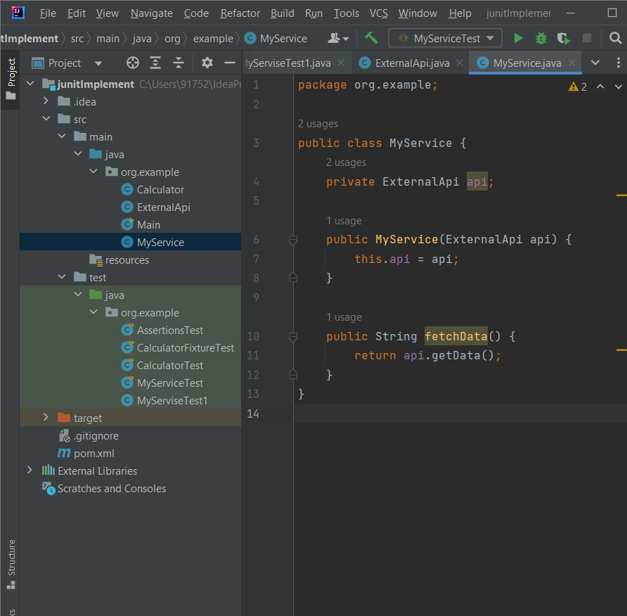

2-MyServiceTest.java

package org.example;  
  
import org.junit.jupiter.api.Test;  
import org.mockito.Mockito;  
  
import static org.mockito.Mockito.\*;  
  
public class MyServiceTest {  
  
 @Test  
 public void testVerifyInteraction() {  
 // Step 1: Create mock object  
 ExternalApi mockApi = Mockito.*mock*(ExternalApi.class);  
  
 // Step 2: Inject mock into service  
 MyService service = new MyService(mockApi);  
  
 // Step 3: Call the method  
 service.fetchData();  
  
 // Step 4: Verify that getData() was called  
 *verify*(mockApi).getData(); // ✅ This passes if called  
 }  
}

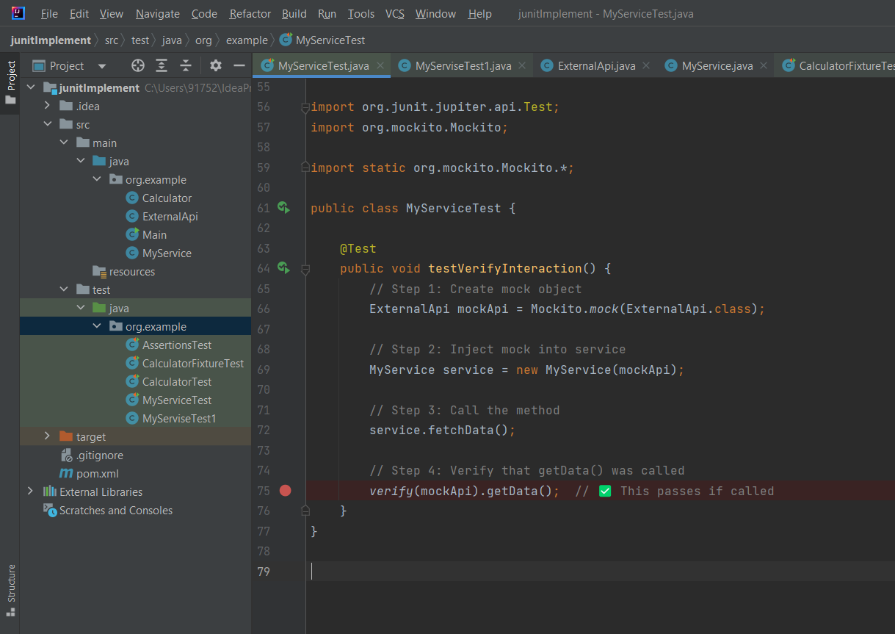

3- ExternalApi.java

package org.example;  
  
public class ExternalApi {  
 String getData() {  
 return null;  
 }  
}

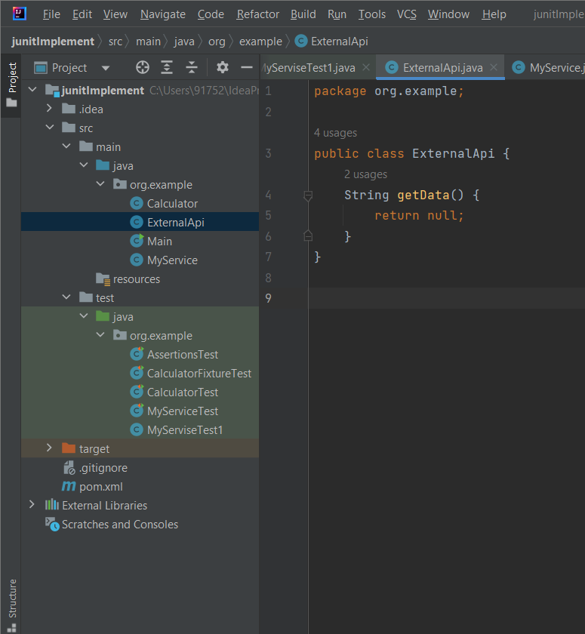

4- Output

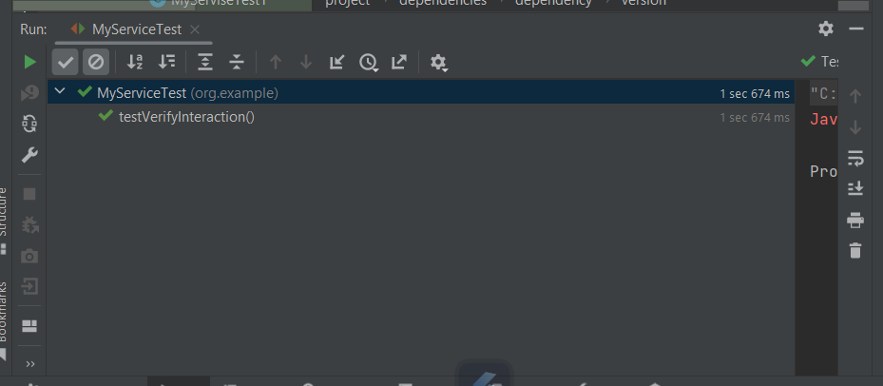

5- pom.xml

<?xml version="1.0" encoding="UTF-8"?>  
<project xmlns="http://maven.apache.org/POM/4.0.0"  
 xmlns:xsi="http://www.w3.org/2001/XMLSchema-instance"  
 xsi:schemaLocation="http://maven.apache.org/POM/4.0.0 http://maven.apache.org/xsd/maven-4.0.0.xsd">  
 <modelVersion>4.0.0</modelVersion>  
  
 <groupId>org.example</groupId>  
 <artifactId>junitImplement</artifactId>  
 <version>1.0-SNAPSHOT</version>  
  
 <properties>  
 <maven.compiler.source>14</maven.compiler.source>  
 <maven.compiler.target>14</maven.compiler.target>  
 <project.build.sourceEncoding>UTF-8</project.build.sourceEncoding>  
 </properties>  
  
 <dependencies>  
 <!-- https://mvnrepository.com/artifact/org.junit.jupiter/junit-jupiter-api -->  
  
 <dependency>  
 <groupId>org.junit.jupiter</groupId>  
 <artifactId>junit-jupiter-engine</artifactId>  
 <version>5.10.0</version>  
 <scope>test</scope>  
 </dependency>  
 <dependency>  
 <groupId>junit</groupId>  
 <artifactId>junit</artifactId>  
 <version>4.13.2</version>  
 <scope>test</scope>  
 </dependency>  
  
 <!-- Mockito -->  
 <dependency>  
 <groupId>org.mockito</groupId>  
 <artifactId>mockito-core</artifactId>  
 <version>5.8.0</version>  
 <scope>test</scope>  
 </dependency>  
  
 </dependencies>  
</project>

